**HTML**

**Image Attribute:**

<img src="img_girl.jpg">

1. **Absolute URL** - Links to an external image that is hosted on another website. Example: src="https://www.w3schools.com/images/img_girl.jpg".
2. **Relative URL** - Links to an image that is hosted within the website.

Example: src="/images/img_girl.jpg".

**The lang Attribute**

You should always include the lang attribute inside the <html> tag, to declare the language of the Web page. This is meant to assist search engines and browsers.

The following example specifies English as the language:

<!DOCTYPE html>  
<html lang="en">  
<body>  
...  
</body>  
</html>

**Tags**

* <mark> - Marked text - Do not forget to buy milk today.
* <del> - Deleted text - My favorite color is  red.
* <ins> - Inserted text - My favorite color is  red.

**HTML Quotation and Citation Elements**

1. **<blockquote> :** 
   1. The HTML <blockquote> element defines a section that is quoted from another source.
   2. Browsers usually indent <blockquote> elements.

**Example:**

<body>

<p>Here is a quote from WWF's website:</p>

<blockquote cite="http://www.worldwildlife.org/who/index.html">

For 60 years, WWF has worked to help people and nature thrive. As the world's leading conservation organization, WWF works in nearly 100 countries. At every level, we collaborate with people around the world to develop and deliver innovative solutions that protect communities, wildlife, and the places in which they live.

</blockquote>

</body>

Here is a quote from WWF's website:

For 60 years, WWF has worked to help people and nature thrive. As the world's leading conservation organization, WWF works in nearly 100 countries. At every level, we collaborate with people around the world to develop and deliver innovative solutions that protect communities, wildlife.

1. **<q> :** 
   1. he HTML <q> tag defines a short quotation.
   2. Browsers normally insert quotation marks around the quotation.

**Example:**

<p>WWF's goal is to: <q>Build a future where people live in harmony with nature.</q></p>

WWF's goal is to: “Build a future where people live in harmony with nature.”

NOTE: q shows the text in the “” where blockquote give the indent to the paragraph.

1. **<abbr> :**
   1. show the global title when mouse over it.
   2. Marking abbreviations can give useful information to browsers, translation systems and search-engines.

**Example:**

<p>The <abbr title="World Health Organization">WHO</abbr> was founded in 1948.</p>

* + World Health Organisation will displayed when mouse overed on WHO.

1. <cite> :
   1. A person's name is not the title of a work.
   2. The text in the <cite> element usually renders in *italic*.

**Example:**

<p><cite>The Scream</cite> by Edvard Munch. Painted in 1893.</p>

*The Scream* by Edvard Munch. Painted in 1893.

1. <bdo> : BDO stands for Bi-Directional Override.
   1. The HTML <bdo> tag is used to override the current text direction:

**Example :**

<bdo dir="rtl">This text will be written from right to left</bdo>

Tfel ot thgir morf nettirw eb lliw emil sihT

**HTML Color**

HTML supports [140 standard color names](https://www.w3schools.com/colors/colors_names.asp)

**Example :**

<h1 style="background-color:DodgerBlue;">Hello World</h1>  
<p style="background-color:Tomato;">Lorem ipsum...</p>

**HTML Links:**

<a href="https://www.w3schools.com/" target="_blank">Visit W3Schools!</a>

* _self - Default. Opens the document in the same window/tab as it was clicked
* _blank - Opens the document in a new window or tab
* _parent - Opens the document in the parent frame
* _top - Opens the document in the full body of the window

**HTML Bookmars:**

Bookmarks can be useful if a web page is very long.

To create a bookmark - first create the bookmark, then add a link to it.

When the link is clicked, the page will scroll down or up to the location with the bookmark.

**Example : just pass the id of the target para corresponse to the link text**

<body>

<p><**a href="#C4"**>Jump to Chapter 4</a></p>

<p><**a href="#C10"**>Jump to Chapter 10</a></p>

<h2>Chapter 3</h2>

<p>This chapter explains ba bla bla</p>

<h2 **id="C4"**>Chapter 4</h2>

<p>This chapter explains ba bla bla</p>

</body>

**Also can be in other page:**

<a href="html_demo.html#C4">Jump to Chapter 4</a>

**HTML Images:**

<img src="*url*" alt="*alternatetext*">

|  |  |  |
| --- | --- | --- |
| **Abbreviation** | **File Format** | **File Extension** |
| **APNG** | **Animated Portable Network Graphics** | **.apng** |
| **GIF** | **Graphics Interchange Format** | **.gif** |
| **ICO** | **Microsoft Icon** | **.ico, .cur** |
| **JPEG** | **Joint Photographic Expert Group image** | **.jpg, .jpeg, .jfif, .pjpeg, .pjp** |
| **PNG** | **Portable Network Graphics** | **.png** |
| **SVG** | **Scalable Vector Graphics** | **.svg** |

**IMAGE Tag:**

**1.<area>:** defines the clickable area in the image

Example:

<img src="workplace.jpg" alt="Workplace" usemap="#workmap" width="400" height="379">  
<map name="workmap">  
  <area shape="rect" coords="34,44,270,350" alt="Computer" href="computer.htm">  
  <area shape="rect" coords="290,172,333,250" alt="Phone" href="phone.htm">  
  <area shape="circle" coords="337,300,44" alt="Cup of coffee" href="coffee.htm">  
</map>

**2. <picture>**

**-** Auto image changes when screen size differs

Example:

<picture>

<source media="(min-width: 650px)" srcset="img_food.jpg">

<!--source media="(min-width: 465px)" srcset="img_car.jpg"-->

<img src="img_girl.jpg" style="width:auto;">

</picture>

**ICON**

<link rel="icon" type="image/x-icon" href="/images/favicon.ico">

* + rel attribute in the <link> tag specifies the relationship between the current document and the linked resource.

**HTML List**

|  |  |
| --- | --- |
| **Tag** | **Description** |
| [**<ul>**](https://www.w3schools.com/tags/tag_ul.asp) | **Defines an unordered list** |
| [**<ol>**](https://www.w3schools.com/tags/tag_ol.asp) | **Defines an ordered list** |
| [**<li>**](https://www.w3schools.com/tags/tag_li.asp) | **Defines a list item** |
| [**<dl>**](https://www.w3schools.com/tags/tag_dl.asp) | **Defines a description list** |
| [**<dt>**](https://www.w3schools.com/tags/tag_dt.asp) | **Defines a term in a description list** |
| [**<dd>**](https://www.w3schools.com/tags/tag_dd.asp) | **Describes the term in a description list** |

**Descrption List**

<dl>  
  <dt>Coffee</dt>  
  <dd>Black hot drink</dd>  
</dl>

**HTML IFrames:**

HTML iframe is used to display a web page within a web page.

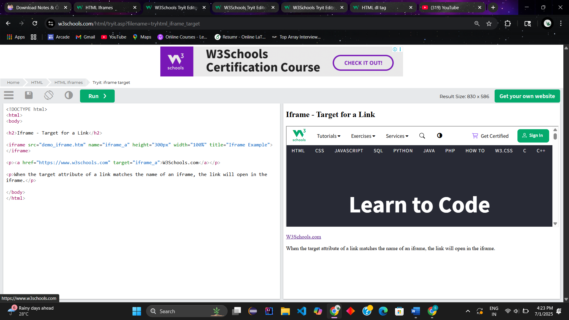<iframe src="*url*" title="*description*"></iframe>

**The HTML <meta> Element :**

The <meta> element is typically used to specify the character set, page description, keywords, author of the document, and viewport settings.

The metadata will not be displayed on the page, but is used by browsers (how to display content or reload page), by search engines (keywords), and other web services.

Examples

* **Define the character set used:**

<meta charset="UTF-8">

* **Define keywords for search engines:**

<meta name="keywords" content="HTML, CSS, JavaScript">

* **Define a description of your web page:**

<meta name="description" content="Free Web tutorials">

* **Define the author of a page:**

<meta name="author" content="John Doe">

* **Refresh document every 30 seconds:**

<meta http-equiv="refresh" content="30">

* **Setting the viewport to make your website look good on all devices:**

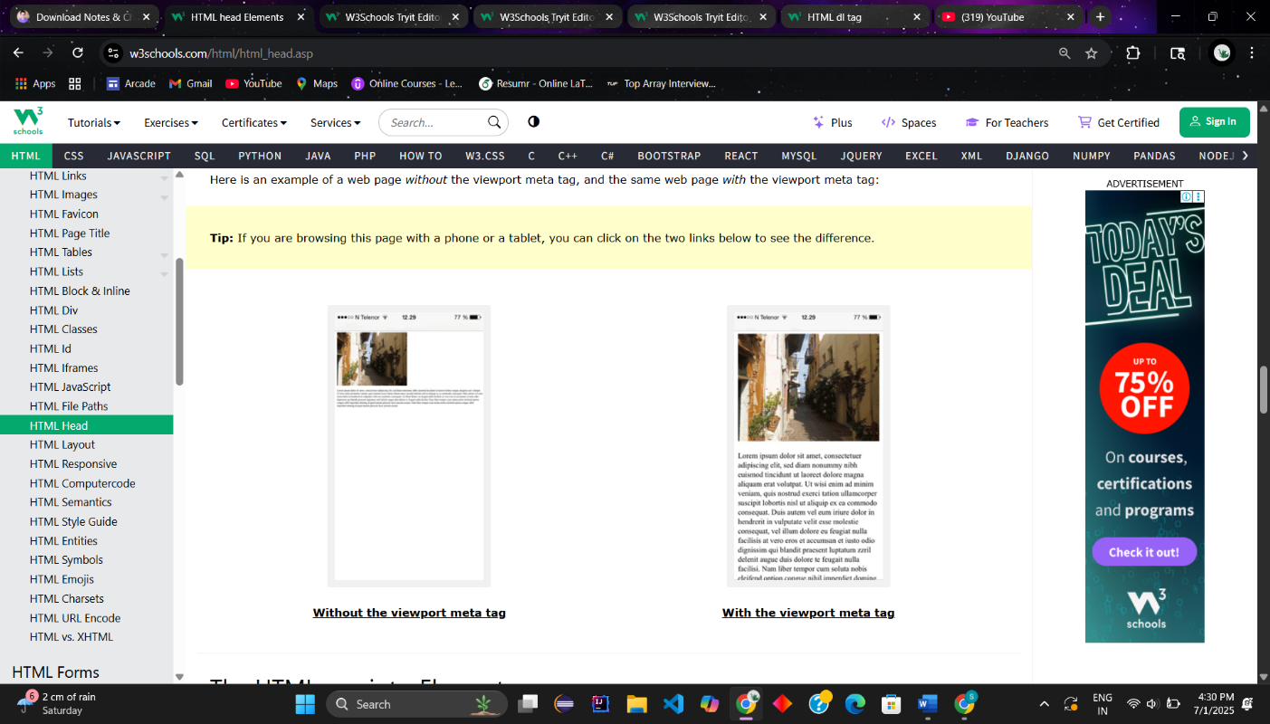<meta name="viewport" content="width=device-width, initial-scale=1.0">

**The HTML <base> Element**

The <base> element specifies the base URL and/or target for all relative URLs in a page.

The <base> tag must have either an href or a target attribute present, or both.

There can only be one single <base> element in a document!

**Example:**

<head>  
<base href="https://www.w3schools.com/" target="_blank">  
</head>  
  
<body>  
<img src="images/stickman.gif" width="24" height="39" alt="Stickman">  
<a href="tags/tag_base.asp">HTML base Tag</a>  
</body>

**HTML Layout Elements**

HTML has several semantic elements that define the different parts of a web page:

|  |  |
| --- | --- |
| HTML5 Semantic Elements | * **<header>** - Defines a header for a document or a section * **<nav>** - Defines a set of navigation links * **<section>** - Defines a section in a document * **<article>** - Defines independent, self-contained content * **<aside>** - Defines content aside from the content (like a sidebar) * **<footer>** - Defines a footer for a document or a section * **<details>** - Defines additional details that the user can open and close on demand * **<summary>** - Defines a heading for the <details> element |

**HTML Computer Code Elements**

**1. <kbd>**

* <kbd> element is used to define keyboard input.
* The content inside is displayed in the browser's default monospace font.

**Example:**

<p>Save the document by pressing <kbd>Ctrl + S</kbd></p>

Result**:**

Save the document by pressing Ctrl + S

**2.<samp>**

* <samp> element is used to define sample output from a computer program.
* The content inside is displayed in the browser's default monospace font.

**Example:**

<p>Message from my computer:</p>  
<p><samp>File not found.<br>Press F1 to continue</samp></p>

Result:

Message from my computer:

File not found.  
Press F1 to continue

**3.** **<code>**

* <code> element  is used to define a piece of computer code.
* The content inside is displayed in the browser's default monospace font.

**Example:**

<code>  
x = 5;  
y = 6;  
z = x + y;  
</code>

Result

x = 5; y = 6; z = x + y;

**4.<var>**

* <var> element  is used to define a variable in programming or in a mathematical expression.
* The content inside is typically displayed in italic.

**Example:**

<p>The area of a triangle is: 1/2 x <var>b</var> x <var>h</var>, where <var>b</var> is the base, and <var>h</var> is the vertical height.</p>

Result:

The area of a triangle is: 1/2 x *b* x *h*, where *b* is the base, and *h* is the vertical height.

**HTML Character Entites**

|  |  |  |  |  |
| --- | --- | --- | --- | --- |
| < | less than | &lt; | &#60; | [Try it »](https://www.w3schools.com/html/tryit.asp?filename=tryhtml_ent_lt) |
| > | greater than | &gt; | &#62; | [Try it »](https://www.w3schools.com/html/tryit.asp?filename=tryhtml_ent_gt) |
| & | ampersand | &amp; | &#38; | [Try it »](https://www.w3schools.com/html/tryit.asp?filename=tryhtml_ent_amp) |
| " | double quotation mark | &quot; | &#34; | [Try it »](https://www.w3schools.com/html/tryit.asp?filename=tryhtml_ent_quot) |
| ' | single quotation mark | &apos; | &#39; | [Try it »](https://www.w3schools.com/html/tryit.asp?filename=tryhtml_ent_apos) |
| ¢ | cent | &cent; | &#162; | [Try it »](https://www.w3schools.com/html/tryit.asp?filename=tryhtml_ent_cent) |
| £ | pound | &pound; | &#163; | [Try it »](https://www.w3schools.com/html/tryit.asp?filename=tryhtml_ent_pound) |
| © | copyright | &copy; | &#169; | [Try it »](https://www.w3schools.com/html/tryit.asp?filename=tryhtml_ent_copy) |
| ® | registered trademark | &reg; | &#174; | [Try it »](https://www.w3schools.com/html/tryit.asp?filename=tryhtml_ent_reg) |
| ™ | trademark | &trade; |  |  |

**HTML Forms**

**1.Method attribute :**

<form action="/action_page.php" method="post">

**2.Novalidate:**

* When present, it specifies that the form-data (input) should not be validated when submitted.

Example:

<form action="/action_page.php" novalidate>

**3.autocomplete:**

gives suggestion of previous filled data to autocomplete.

Example:

<form action="/action_page.php" autocomplete="on">

**The HTML <form> Elements**

* <input>
* <label>
* <select>
* <textarea>
* <button>
* <fieldset>
* <legend>
* <datalist>
* <output>
* <option>
* <optgroup>

**1.<fieldset> and <legend> elements: make the form in the box on edge written Personalia**

* The <fieldset> element is used to group related data in a form.
* The <legend> element defines a caption for the <fieldset> element.

Example:

<form action="/action_page.php" target=”_blank”>  
  <fieldset>  
    <legend>Personalia:</legend>  
    <label for="fname">First name:</label><br>  
    <input type="text" id="fname" name="fname" value="John"><br>  
    <label for="lname">Last name:</label><br>  
    <input type="text" id="lname" name="lname" value="Doe"><br><br>  
    <input type="submit" value="Submit">  
  </fieldset>  
</form>

**2.<datalist>:**

The <datalist> element specifies a list of pre-defined options for an <input> element.

Example: Dropdown

<form action="/action_page.php">  
  <input list="browsers">  
  <datalist id="browsers">  
    <option value="Edge">  
    <option value="Firefox">  
    <option value="Chrome">  
    <option value="Opera">  
    <option value="Safari">  
  </datalist>  
</form>

**HTML Input Types**

Here are the different input types you can use in HTML:

* <input type="button">
* <input type="checkbox">
* <input type="color">
* <input type="date">
* <input type="datetime-local">
* <input type="email">
* <input type="file">
* <input type="hidden">
* <input type="image">
* <input type="month">
* <input type="number">
* <input type="password">
* <input type="radio">
* <input type="range">
* <input type="reset">
* <input type="search">
* <input type="submit">
* <input type="tel">
* <input type="text">
* <input type="time">
* <input type="url">
* <input type="week">

**HTML Input Attributes:**

1. value : for pre-defined value

2.readonly – can not modify

3. disabled – unclickable

4. size – no of digits it will allow to store

Example : <input type="text" id="pin" name="pin" size="4">

5. maxlength – no of characters allowed 1 - 9999

Example : input type="text" id="pin" name="pin" maxlength="4" size="4">

6. Min and Max : tells the minimum and maximum allowed range of digit

Example: label for="quantity">Quantity (between 1 and 5):</label>  
   <input type="number" id="quantity" name="quantity" min="1" max="5">

7. multiple : users is allowed to enter multiple value

Eaxmple : <input type="file" id="files" name="files" multiple>

8. pattern : which type of value is allowed(only 3 characters are allowed)

Example : <input type="text" id="country_code" name="country_code"  
  pattern="[A-Za-z]{3}" title="Three letter country code">

9. autofocus : focus the field on page load

Example : <input type="text" id="fname" name="fname" autofocus>

10. list : refers to a <datalist> element that contains pre-defined options for an <input> element.

Example:

<form>  
  <input list="browsers">  
  <datalist id="browsers">  
    <option value="Edge">  
    <option value="Firefox">  
    <option value="Chrome">  
  </datalist>  
</form>

**HTML Video and Audio**

**1. <video> :**

controls attribute adds video controls, like play, pause, and volume.

**Example:**

<video width="320" height="240" controls>  
  <source src="movie.mp4" type="video/mp4">  
  <source src="movie.ogg" type="video/ogg">  
Your browser does not support the video tag.  
</video>

**2. <audio>:**

controls attribute adds audio controls, like play, pause, and volume.

Autoplay – starts the music as page loads automatically.

**Example:**

<audio controls autoplay>  
  <source src="horse.ogg" type="audio/ogg">  
  <source src="horse.mp3" type="audio/mpeg">  
Your browser does not support the audio element.  
</audio>

**POINTS:**

Charset : specify the character encoding for the HTML document

* + Setting the correct charset ensures that text is interpreted and displayed correctly by the browser — especially for special characters like emojis, non-English alphabets (like हिंदी, 中文, عربى), or symbols (€, ©, ✓).

Example :

<!DOCTYPE html>

<html lang="en">

<head>

<meta charset="UTF-8">

<title>My Page</title>

</head>

<body>

<p>Hi! नमस्ते! 你好! 🌍</p>

</body>

</html>

**Note** : Without charset="UTF-8", you might see weird symbols like � instead of proper characters.

Rel : attribute is used to specify the relationship between the current document and the linked document in the <a> tag

Ico : favicon extension

<figure><img src="image.jpg"><figcaption>Image Caption</figcaption></figure> : inserting an image with a caption

<cite> : used to define a citation in HTML

<noscript> :  Script to be run if scripting is disabled(like execute the tage contains text if js is not executing

Example:

<noscript>

<p>Your browser does not support JavaScript or it is disabled. Please enable JavaScript to view this site properly.</p>

</noscript>

<input type="submit"> : create a button that submits a form

<input type="reset"> : creating a button that resets a form

<title> :  adding a tooltip to an element

<strong> : important text that should be emphasized

Title : alternate text of area in image map

<basefont> : define the base font size for the document